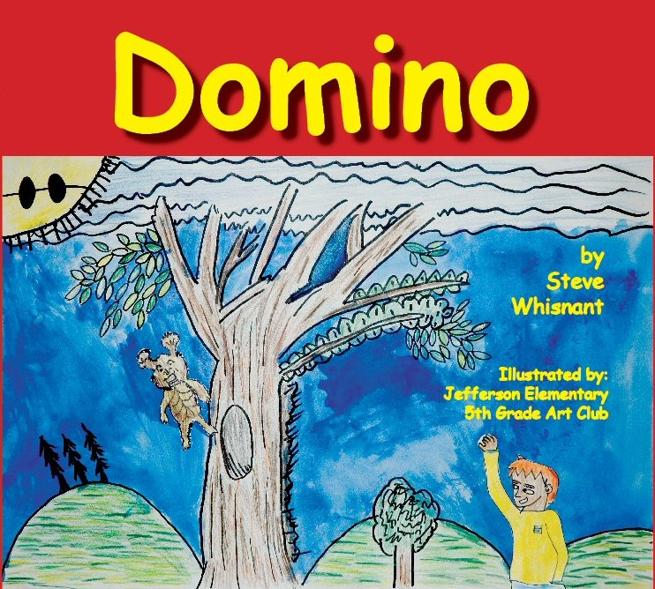  By  Steve  Whisnant  Illustrated by:  Jefferson Elementary  5th Grade Art Club    SkyMacSyd  Publishing  www.stevewhisnant.com | By  Steve  Whisnant  Illustrated by:  Jefferson Elementary  5th Grade Art Club  SkyMacSyd  Publishing  www.stevewhisnant.com | By  Steve  Whisnant  Illustrated by:  Jefferson Elementary  5th Grade Art Club  SkyMacSyd  Publishing  www.stevewhisnant.com | By  Steve  Whisnant  Illustrated by:  Jefferson Elementary  5th Grade Art Club  SkyMacSyd  Publishing  www.stevewhisnant.com | By  Steve  Whisnant  Illustrated by:  Jefferson Elementary  5th Grade Art Club  SkyMacSyd  Publishing  www.stevewhisnant.com

